Week 06

**Question 1:**

**Given an array A of sorted integers and another non negative integer k, find if there exists 2 indices i and j such that A[i] - A[j] = k, i != j.**

**Program:** 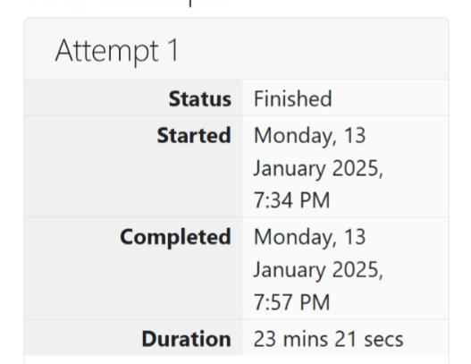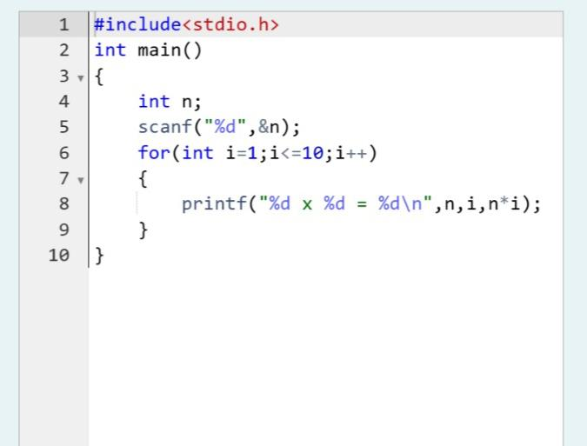

**Output:** 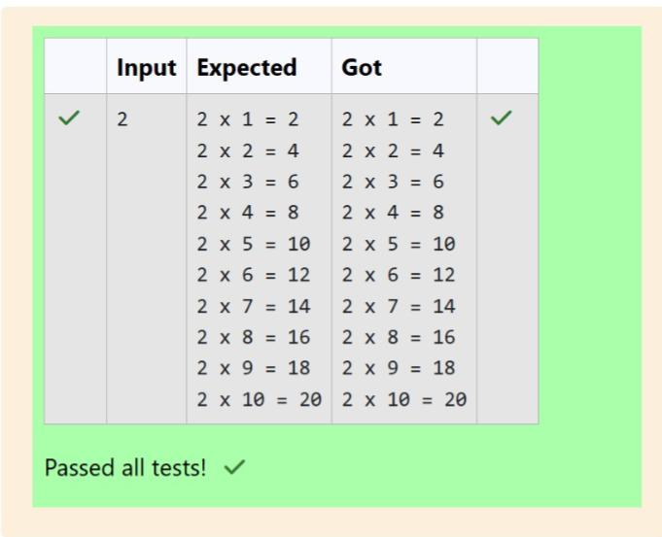

**Question 2:**

**Sam loves chocolates and starts buying them on the 1st day of the year. Each day of the year, x, is numbered from 1 to Y. On days when x is odd, Sam will buy x chocolates; on days when x is even, Sam will not purchase any chocolates. Complete the code in the editor so that for each day Ni (where 1 ≤ x ≤ N ≤ Y) in array arr, the number of chocolates Sam purchased (during days 1 through N) is printed on a new line. This is a function-only challenge, so input is handled for you by the locked stub code in the editor.**

**Program:** 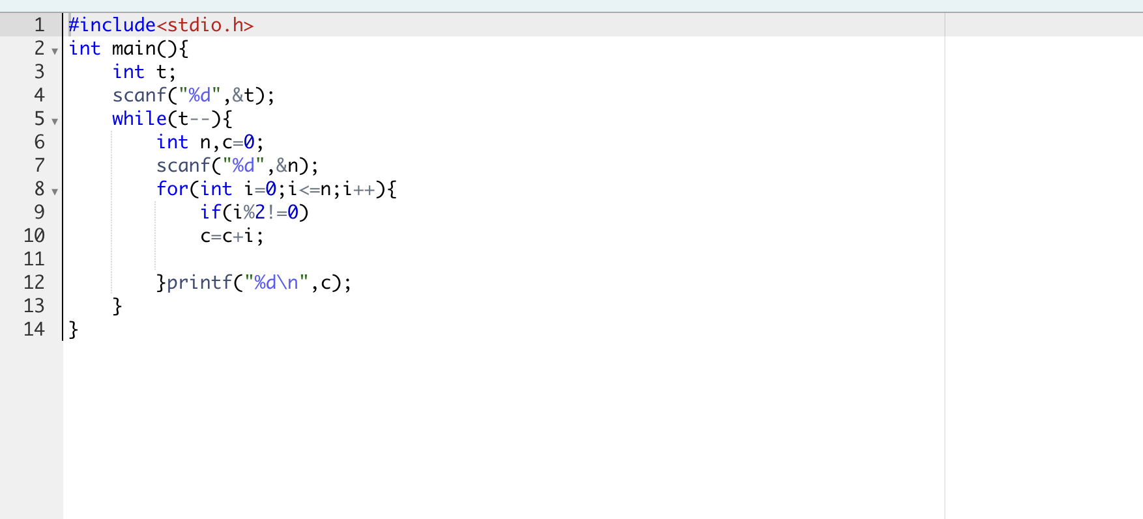

**Output**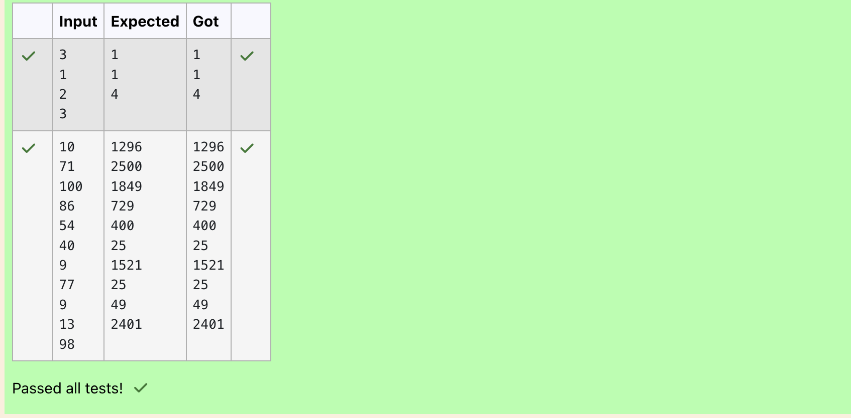

**Question 3:**

**The number of goals achieved by two football teams in matches in a league is given in the form of two lists.**

**Program:** 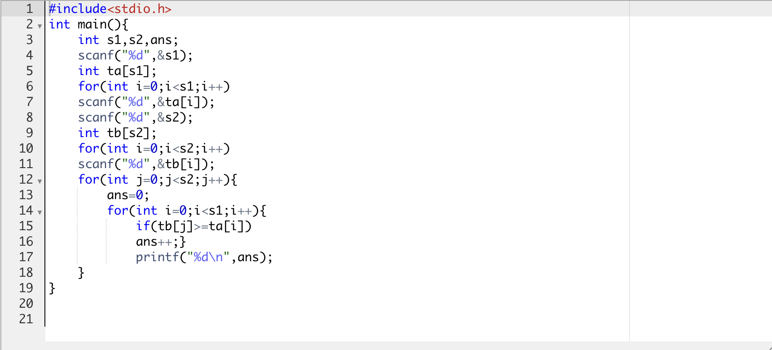

**Output:**

